**Daily Scrum or Standup Meeting**

Team name: ______Group 2___________________

Scrum Master: ____Emily___________________

Date:________10/10_______________________

| **Team Member** | **What did you do since the last scrum?** | **What do you plan to do before the next scrum?** | **What obstacles do you have?** |
| --- | --- | --- | --- |
| Emily | Set up a variable for calculating how much money is owed by the manager to purchase inventory | See if I can help with connecting inventory items to menu items | Time |
| Karl Poulson | Finished the template design of the UserView | Refactor code, set up manager view | Finding the correct resources and the right layout. |
| Andre Nguyen | Updated the addDrink method to have a new table. Try to restart the implementation of removeDrink | Wrap up those two methods and see if I can start implementing the edit/change drink | Learning how to access the django database and use it in views |
| Maris Hurst | Pulled down updated merged code and copied user auth things to correct place | Connect to views including various user types | Time (other classes) |
|  |  |  |  |

# Burndown

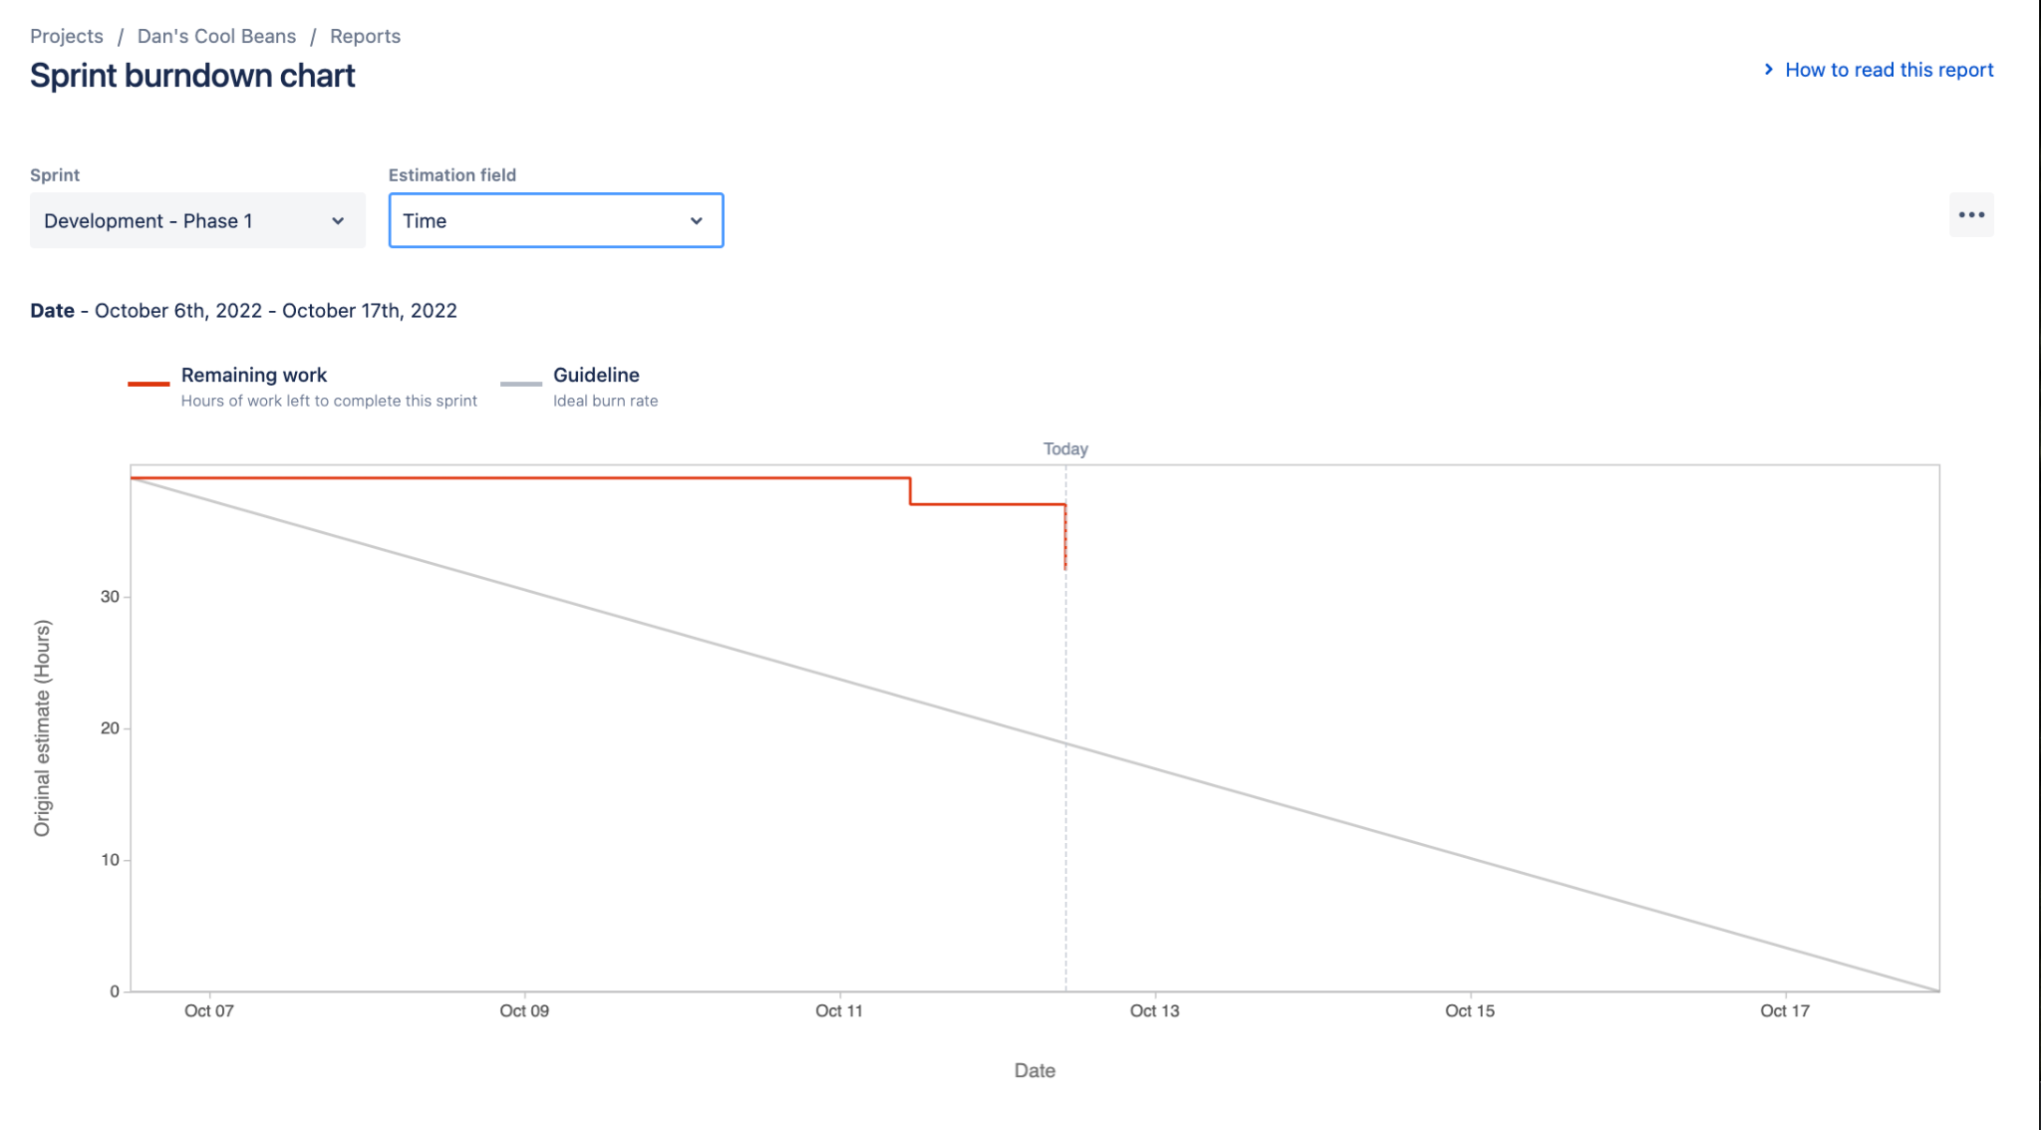

# Screenshot of you project board

